Quarterly Product Release

Version 23.4.0.0



C

ONTACTS

info@uppwise.com

[LinkedIn Company Profi](https://www.linkedin.com/company/uppwise)le

[www.uppwise.c](http://www.uppwise.com/)om

Release Note

Quarterly Product Release Version 23.3.0.1



C

ONTACTS

info@uppwise.com

[LinkedIn Company Profi](https://www.linkedin.com/company/uppwise)le

[www.uppwise.c](http://www.uppwise.com/)om

This serves as a Feature Release Note to apprise our customers of the latest addition to the application, released with the Uppwise 2023 **Quarter 4 release 23.4.0.0**

# Feature 1: WF single configuration pop-up

Introducing a novel configuration icon dedicated to Workflow (WF) settings, providing a centralized hub for streamlined management of all configurations.

**Below are few key points of this feature:**

* Centralized configuration settings in a single popup window
* Tab-based layout in the popup for organized and standardized configuration sections.
* Active indicator to highlight the current tab, enhancing user navigation and clarity in customization.
* In all tabs switcher is added for enabling the sections
* User Experience changed over Form Section, Advance Options and Associate initiative layouts

**Single Configuration icon appearance** 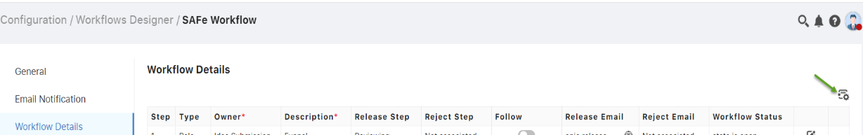

**Single window appearance (when click on icon)**

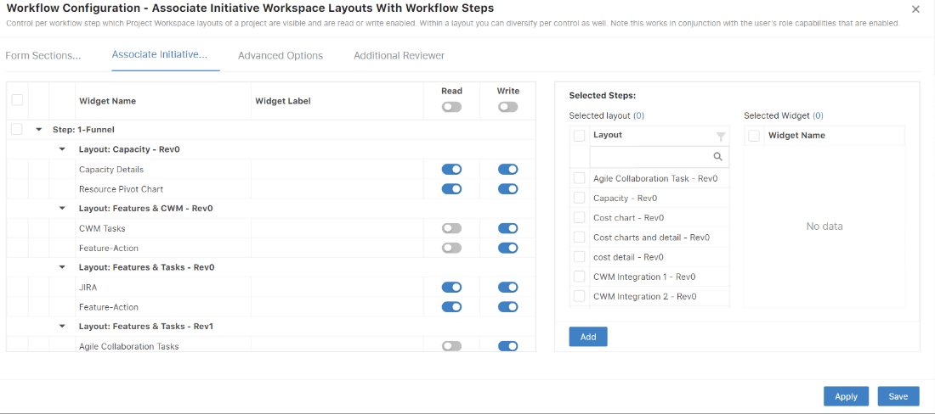

# Feature 2: Collaboration and Project – Provide possibility to add ‘Identification’ section in Workflow form section window

## For Collaboration & Initiative: -

The Identification section is now active in the workflow form, allowing users to specify read-only or write permissions across different steps. This enhancement provides precise control over access rights throughout the workflow stages.

**Key points of this feature:**

* The initial step of the workflow is deactivated during implementation as the enable/disable identification section doesn't apply to the first step, and the default permission is set to write.
* For subsequent workflow steps, the default permission is set to read-only, with users having the flexibility to adjust permissions as needed.

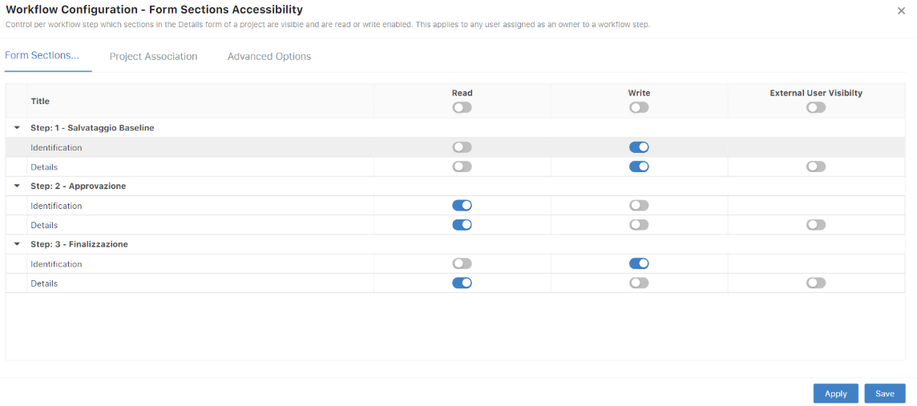

# Feature 3: Implementation of Geo coordinates over Location and Country page

Two new columns, 'Longitude' and 'Latitude,' have been incorporated into the Standard code for both Country and Location pages.

These information of Latitude and Longitude has been updated from backend (taking the reference from a Geo Google source). These entries can be modified as per the user requirement if required.

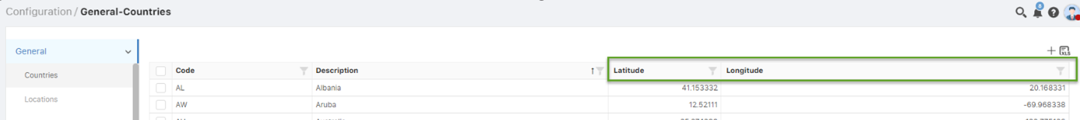

# Feature 4: Implementation of custom action (Extension hooks)

This feature aims to establish a connection with an external service by leveraging application events (for example, below events) as the triggering mechanism.

* Resource Assignment create/Update.
* Cost assignment creation/update.

**Configuration at company level:**

1. A new Setting added on company page where admin user can do the required configurations.

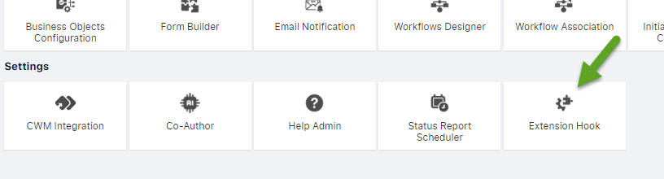

1. Below pop-up opens on the click on Extension hook icon where user can provide external Api link which will be execute on the bases of any specific event.

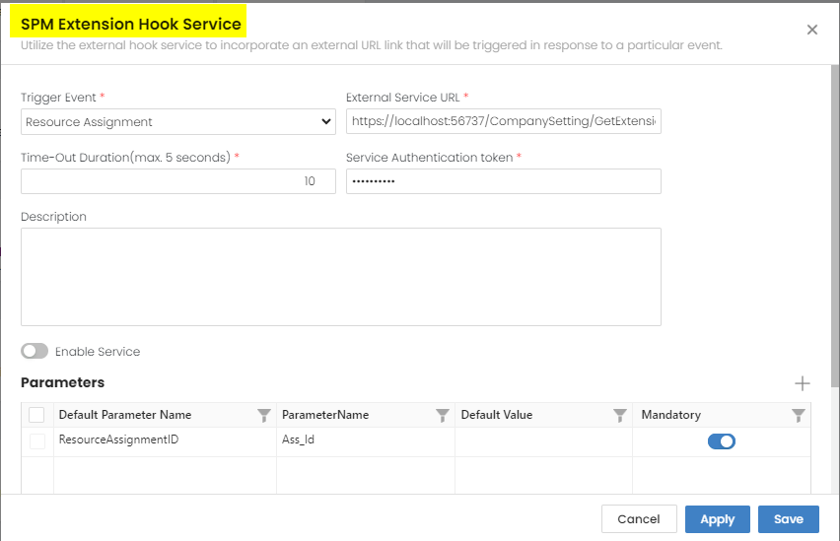

# Feature 5: Hierarchical Map in Strategy module

A strategy module's hierarchical map visually represents the structure of strategic elements within an organization, depicting relationships and dependencies between different levels. Color-coded elements are used for easy identification:

* **Red:** Summarizes hierarchical elements at the Strategy level.
* **Grey:** Displays associated Themes data.
* **Orange:** Represents associated Objectives with the themes.
* **Pink:** Illustrates associated Projects.
* **Blue:** Indicates associated Key Results.

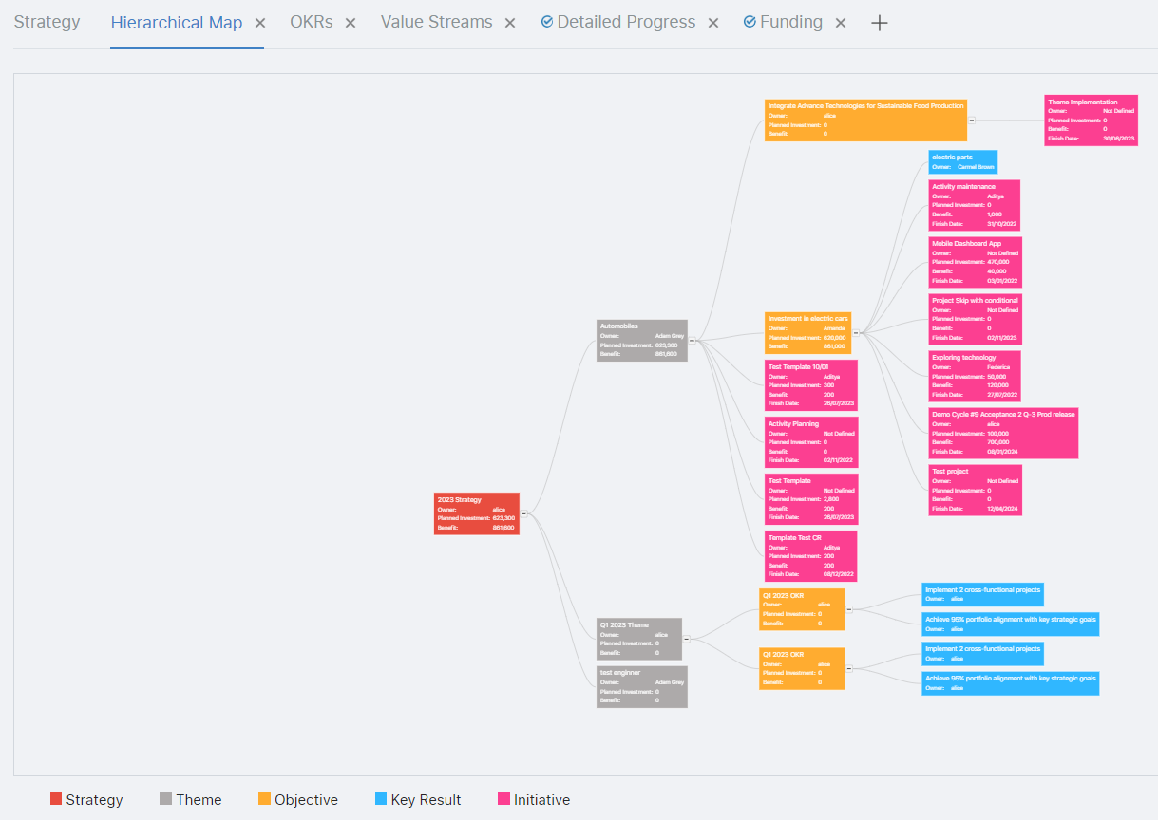

# Feature 6: Increase the number of COS characters

**Feature Release Summary:**

The proposed adjustment involves raising the limit to 100 characters in order to more effectively address customer requirements. In the updated feature development, this enhancement now enables the inclusion of up to 120 characters COS node descriptions, thereby meeting user demands more comprehensively.

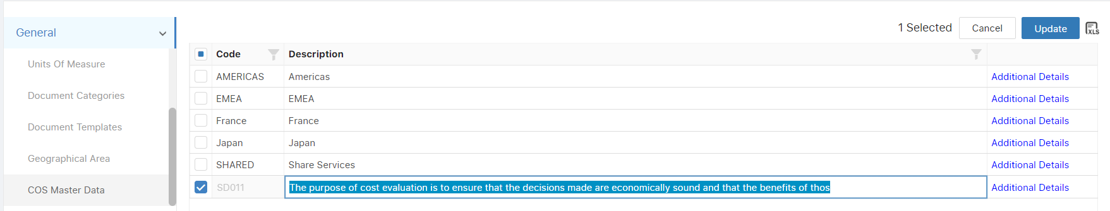

# Feature 7: Graphical change to the Risk Matrix

The graphical representation of the risk matrix has been improved, with each column now having an equal size. This enhancement ensures a more standardized and visually consistent display of risk assessment data, facilitating clearer interpretation and comparison of risk scores across different categories.

The enhancement has been applied across various sections of the application, ensuring consistent column sizes for improved visual coherence in areas such as initiatives, programs, and portfolios.

**Managed this in all over the application where the risk matrix available like Initiative, program, portfolio.**

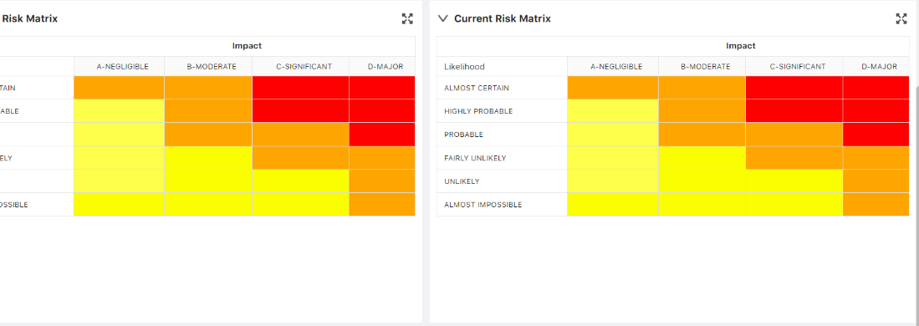

# Feature 8: Top/down planning (Cost Management)

# The Top-down planning functionality under Cost Management in the SPM standard application enables users to allocate costs among various cost elements within the same task or across different tasks. This inherent feature allows for efficient distribution or reallocation of costs to other cost elements.

# Key references of this feature include:

# Users with permission to access the cost widget within the initiative workspace can perform Top-down planning of forecasted values.

# Top-down planning is restricted to the element type, meaning that if the assignment type is revenue, the distribution of the value is limited to revenue elements only, and the same applies to cost elements.

# The feature provides two options for distributing values in top-down planning: one using assigned cost values and the other utilizing assigned cost percentages.

# The functionality does not apply to Cost assignments with actuals.

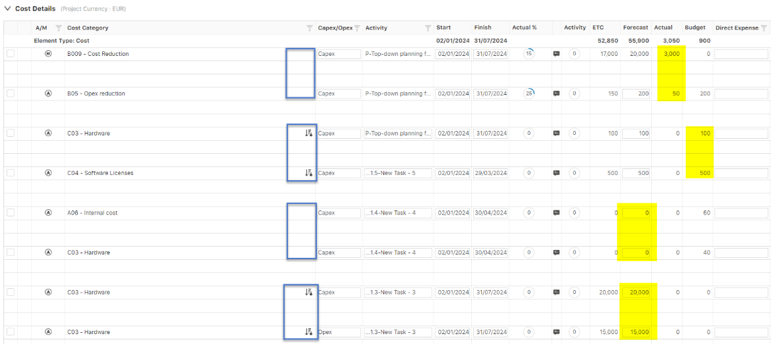

# Feature 9: Separate login links in the email

As per this new feature, there are two variables incorporated in email notification. These variables are named as "SSO" and "Web Authentication." This addition aims to manage the object link from this section, ensuring that users receive appropriate notifications based on the selected authentication method.

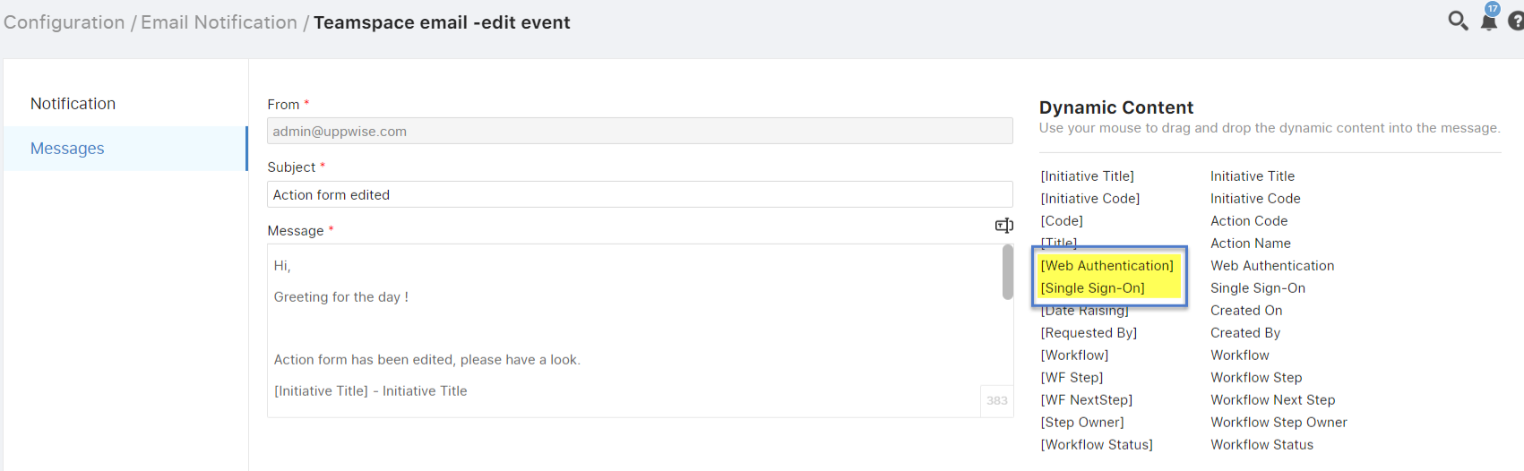

# Feature 10: Template Management

A new feature in the Initiative module, "Template Management," facilitates the creation, organization, and use of standardized templates for project-related documents, processes, or tasks. These templates serve as predefined formats that can be easily replicated and customized for different projects or phases.

**Below are few key points of this feature:**

A new permission is added under the Initiatives.

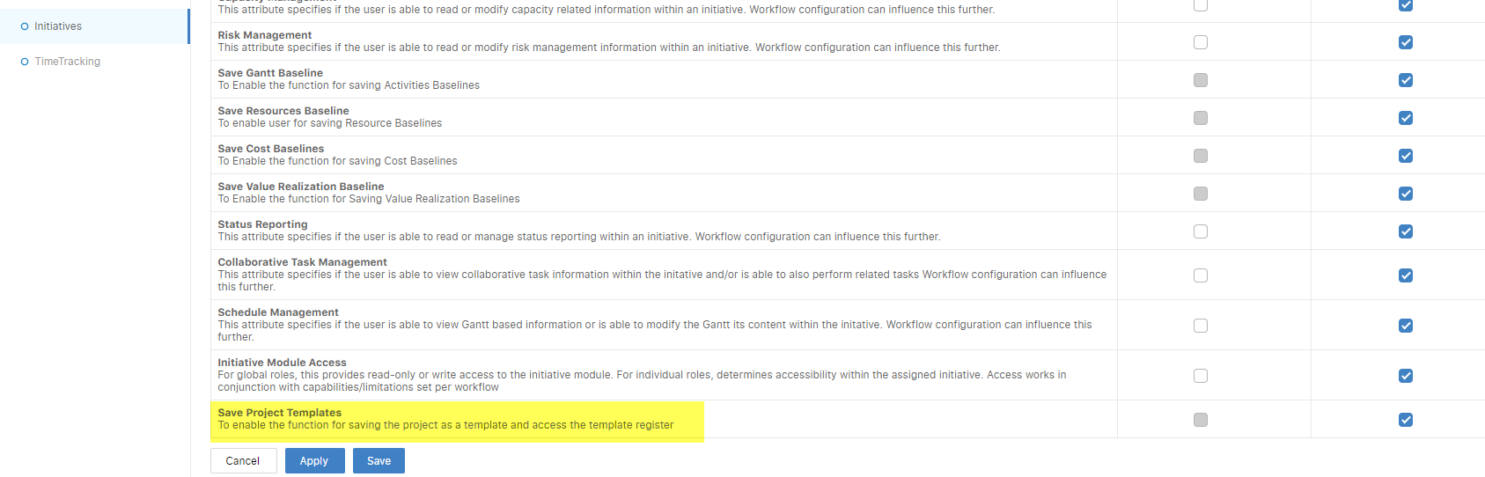

Users with the specified permission are able to save the project as a template (Only Draft projects) and subsequently access it through the Template Register.

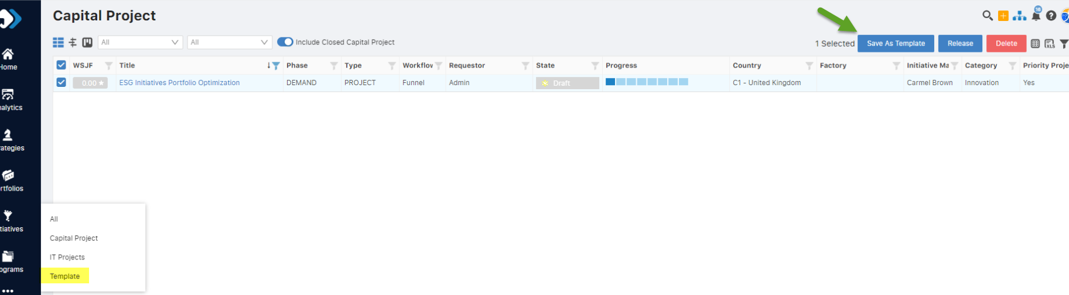

Users can now create a new project from saved templates using the redesigned Quick New Project pop-up. Refer to the screens for both functionalities.

**Quick new Project:**

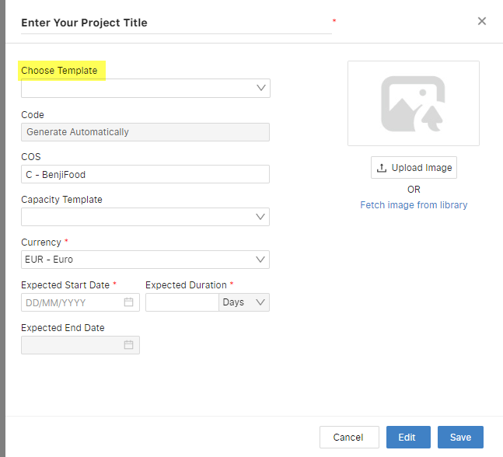

**Create project from template (after selection of template):**

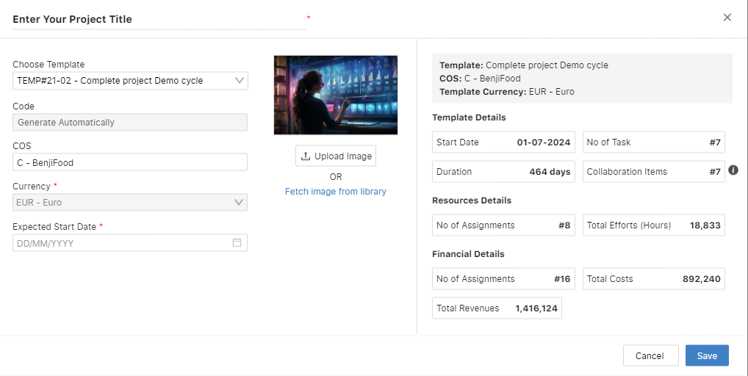

**Feature 11:** **SSO Improvement**

Signing algorithm has been improved from SHA-1 to SHA-256 strengthens the security posture of the SSO system, enhances data integrity, ensures compliance with industry standards, and helps mitigate the risks associated with cryptographic vulnerabilities

**Feature 12: Implementation of Gen AI in SPM Strategy Module**

We introduced Co-author, a Gen AI-powered tool in the Strategy Module, generating comprehensive information like summaries, missions, visions, milestones, themes, OKRs (Objectives and Key Results), etc.

**Below are few key points of this feature:**

Accessibility permission is added over User profile related to Co-Author.

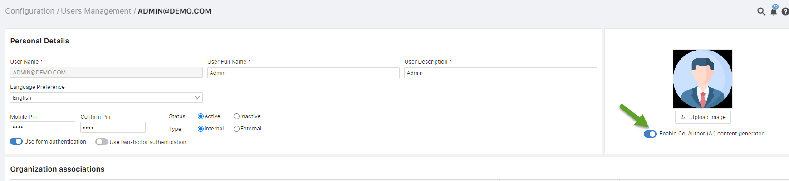

Users with the above permission will access the Co-author functionality by identifying the Co-author icon (Chat window – see below screenshot) conveniently positioned over the Strategy interface, facilitating seamless utilization of its features.

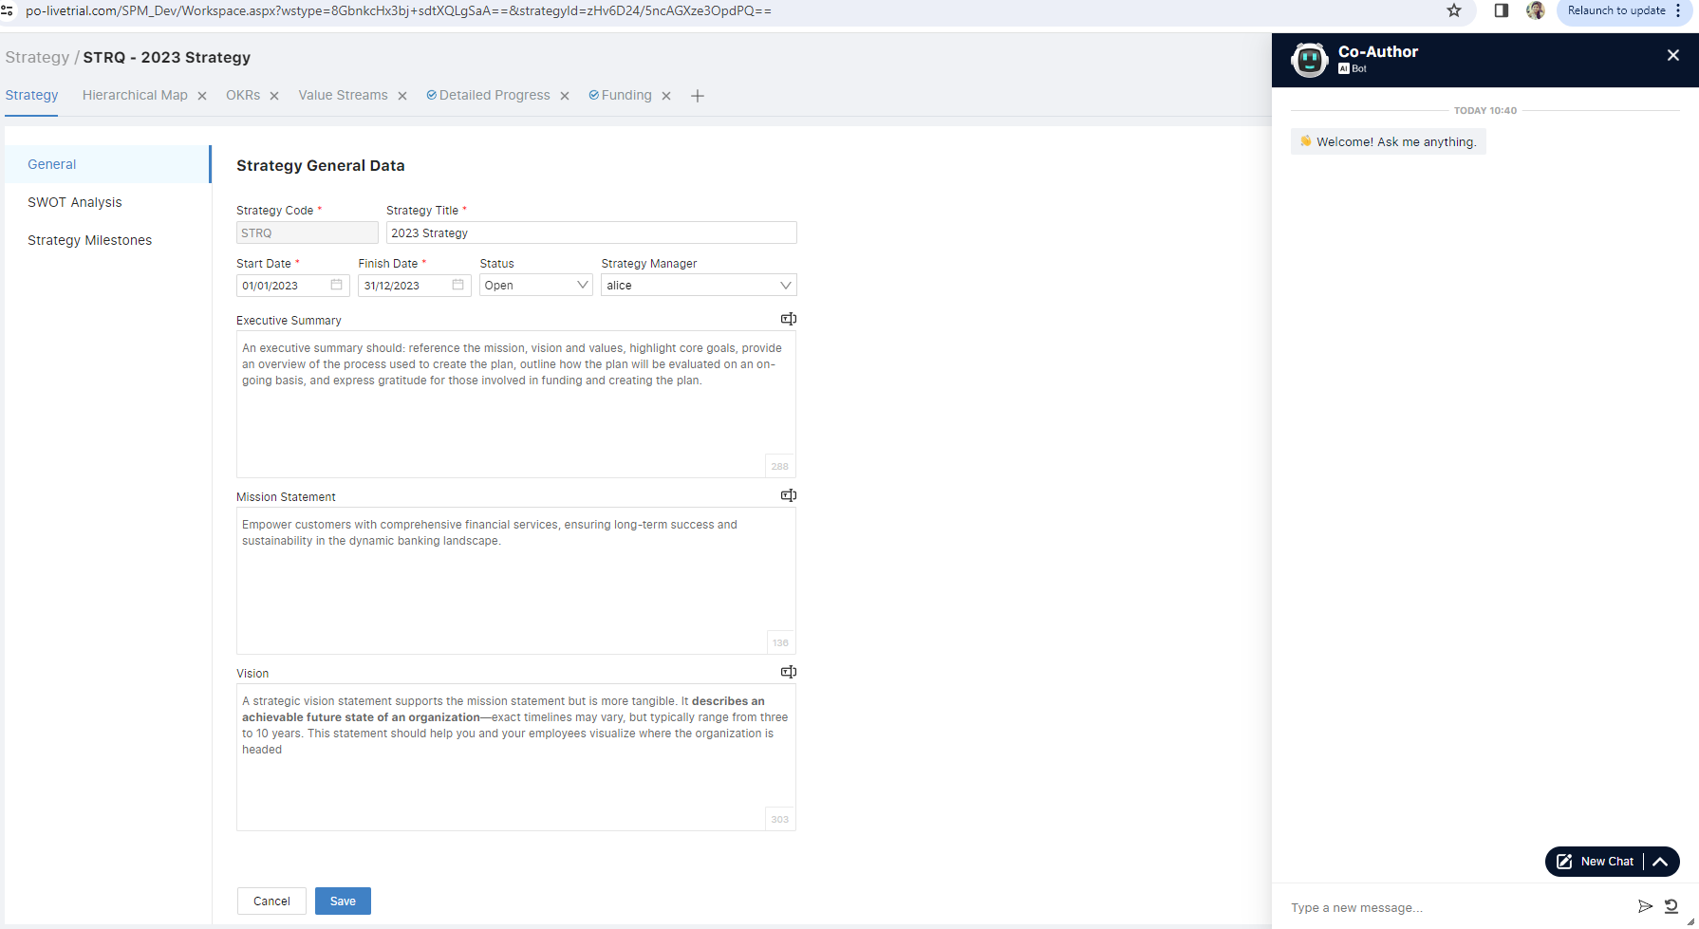

**Analytic Feature Release – Q4**

# Feature 1: Copy Report

The addition of the copy feature in web reporting enables end-users to save and reuse a report as a template, including report items, data source, data binding, and layout settings, by storing it as an XML definition.

To create a duplicate copy of an existing report, users can simply click the "Copy Report" button associated with the desired report in the Report Register.

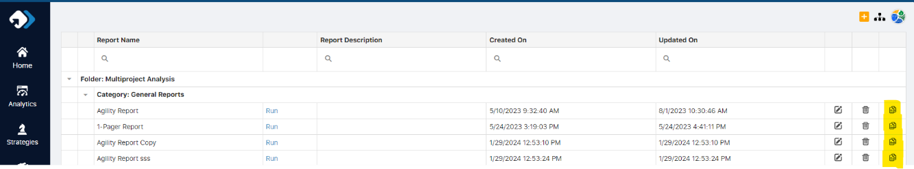

# Feature 2: Funnel dashboard custom item

A Funnel dashboard item is a chart displaying data with decreasing proportions, useful for visualizing process stages like a sales pipeline where item numbers decrease at each stage.

1. On Clicking the Funnel icon, user can move to funnel dashboard widget.

1. In bindings user can select the data to be binded with the widget.

**Feature 3: Raw data visibility feature “Inspect Data”**

Data Inspector is a dialog displaying raw or aggregated data. It has one or two grids, switchable via a radio group. The Inspect Data icon, located at the top right corner of widgets, click of the inspect data, it opens the data popup, with radio button options for Raw and Aggregated views.

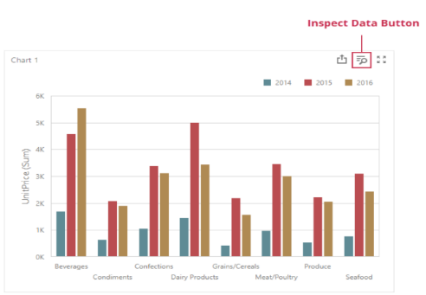

# Feature 4: Supported data sources for online map dashboard custom item

The data sources for the online map item are:

* ProjectLocationSqlDs
* InitiativeRegisterSqlDsView

These sources include information such as location, longitude, latitude, and project code for mapping. Also To associate locations with initiatives, users must select a location from the dropdown list in initiative details during creation.



# Feature 5: Online map dashboard custom item

The online map item allows users to place callouts on Google or Bing maps using geographical coordinates (Longitude & Latitude). It's used to visualize data related to specific zones or regions like districts, floors, or products.

To use - The online map item is available in the dashboard toolbox under custom items.:

* Drag and drop the item from the dashboard toolbox.
* In Binding, provide the initiative’s geographical coordinates from supported data sources.

# Feature 6: Strategy Roadmap view data source development

**Strategy Road Map:** vwStrategyRoadmap (Data Source)

Using the below view, now the Gantt chart control is able to show all the available Projects and its timeline.

